Ideation Phase

Define the Problem Statements

Date | 8 December 2025
Team ID | SWUID60312
Project Name | Medifolio - Doctor Appointment Booking  System
Maximum Marks | 2 Marks

Customer Problem Statement Template:
Medifolio is designed to overcome the common challenges patients experience when trying to secure timely medical appointments. Many people find it difficult to locate the right doctor, view availability, and book appointments without facing delays. Clinics, on the other hand, often struggle with managing patient records, organizing schedules, and handling manual booking processes. These issues contribute to long wait times, miscommunication, and lower patient satisfaction. Medifolio provides a streamlined digital solution that simplifies appointment booking for patients while enhancing operational efficiency for clinics.

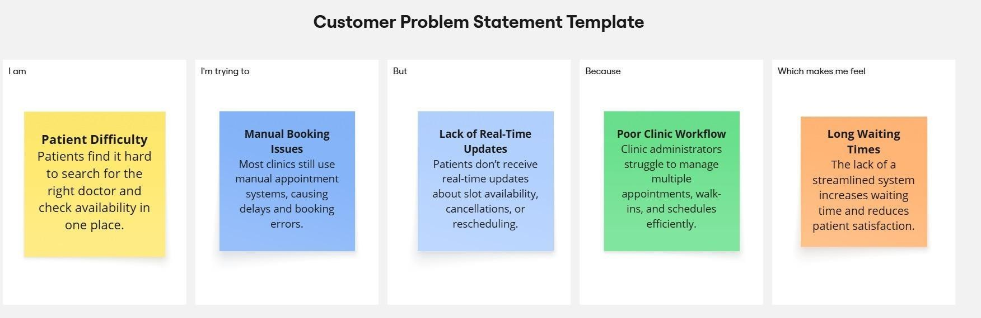

Problem Statement (PS) | I am (Customer) | I’m trying to | But | Because | Which makes me feel
PS-1 | A patient looking for a nearby doctor. | Book a medical appointment quickly an ctor schedules efficiently d  check the doctor’s  availability. | Most clinics still rely on manual booking, and the available online options are limited or poorly  organized. | There is no unified system that displays doctors, their schedules, and the services they offer in one place. | Frustrated and stressed, especially during urgent health concerns.

PS-2 | A clinic administrator  . | Manage patient bookings and doctor schedules efficiently. | There is no automated system to manage appointments, cancellations, or patient information. | Overwhelmed and unable to maintain smooth clinic operations.

